AATI National Conference at Marist:
Locations Map
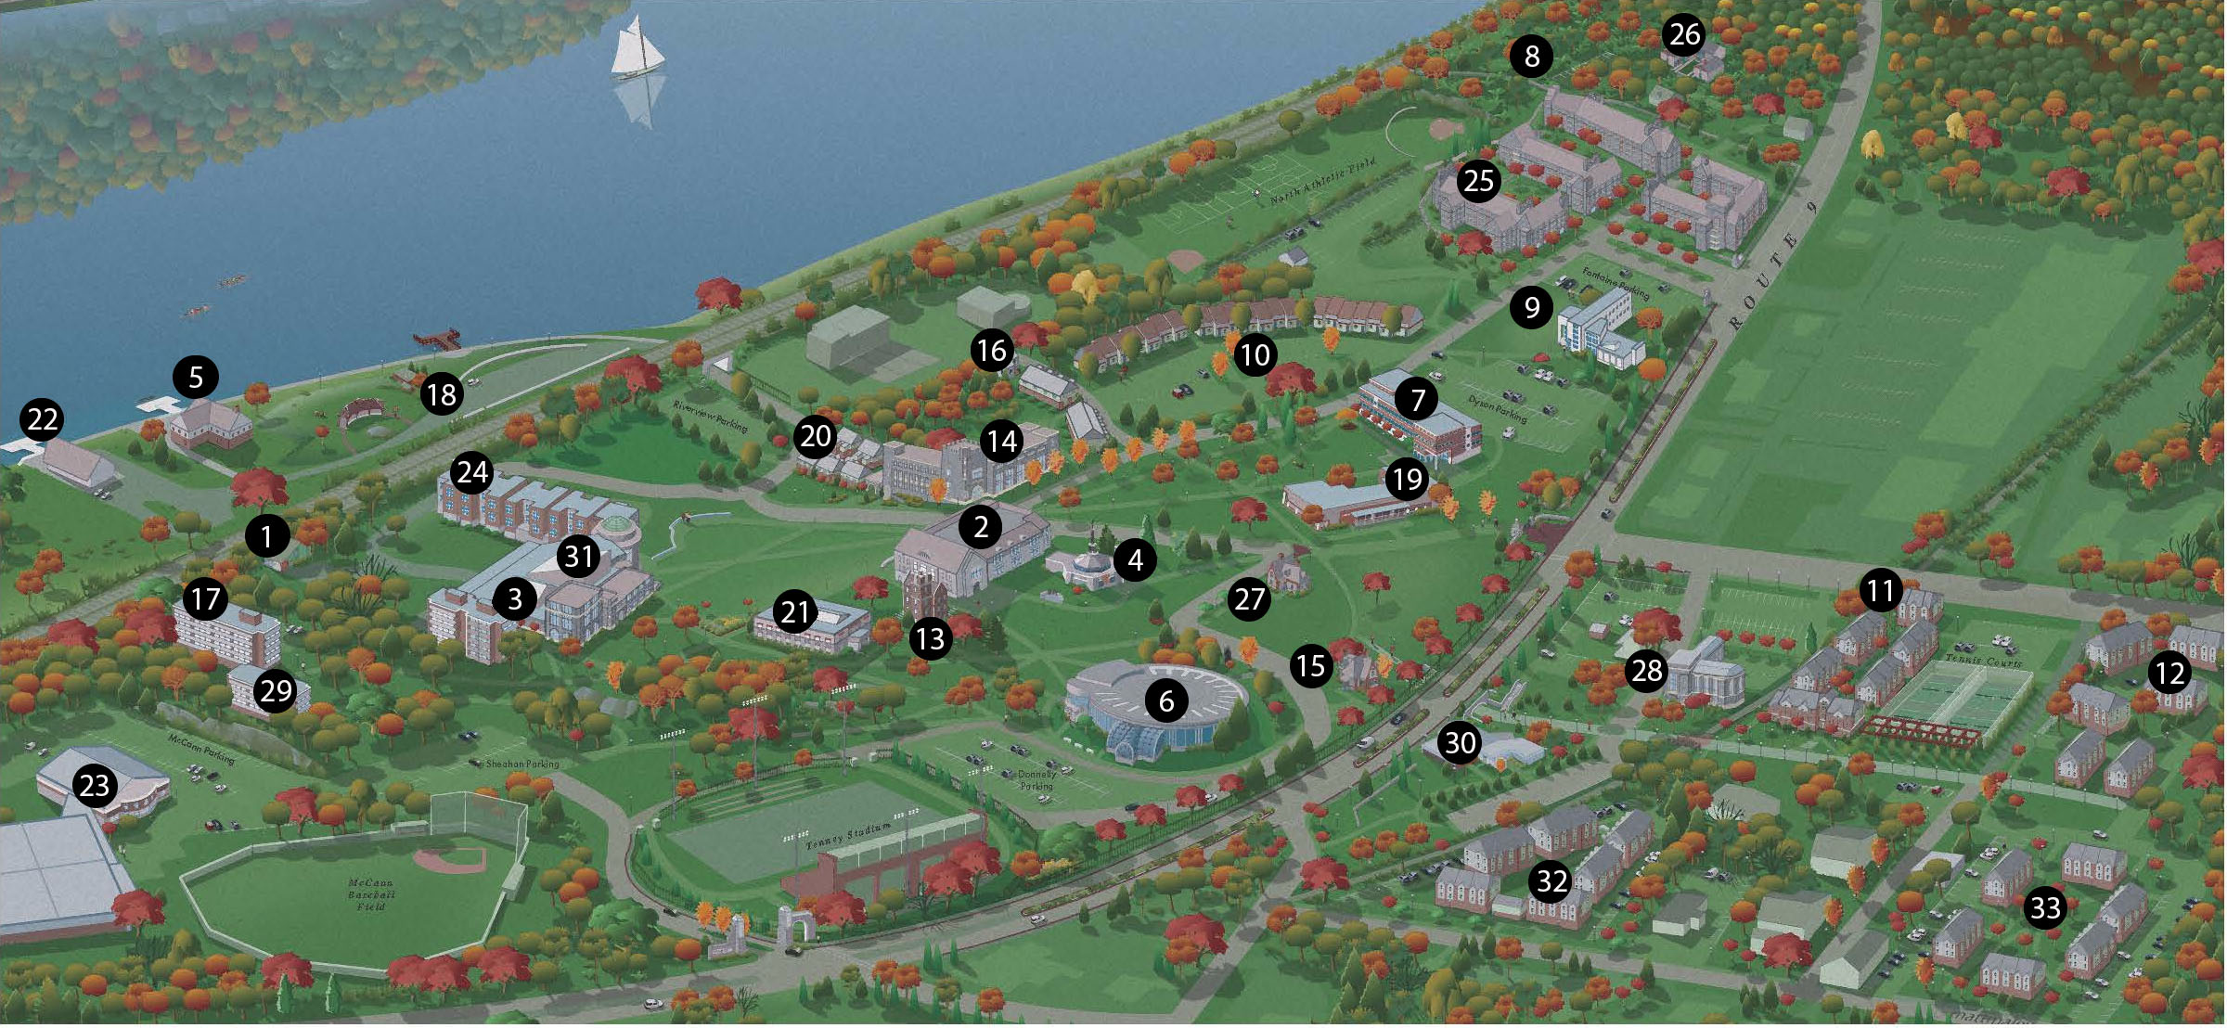

**FIRST STOP! Location 19 – Lowell Thomas Bldg. – Check-in and Conference Sessions **
Other locations for conference events:
2 – James Cannavino Library – Weiss Center Workshops
6 – Donnelly Hall – Café open: Mon-Fri 7:30 am – 3:00 pm
9 – Fontaine Hall – AATI Advocacy Committee Mtg. & Exec. Board Meetings
20 – Lower New Townhouses – Guests Dorms
31 – Murray Student Center – Nelli Goletti Theatre (Keynote Speeches)

